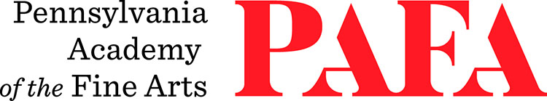
Continuing Education Programs
mATERIALS LIST
Course: Painting Beyond Representation
Instructor: Roger Chavez
Days/Dates: 6wks, Fridays, September 25 – October 30
Time: 10:00 a.m. – 1:00 p.m.
Location: Room 463 / Samuel M.V. Hamilton Building
128 N. Broad Street, Philadelphia, PA 19102 (Use Student Entrance on Lenfest Plaza / Cherry Street)

MATERIALS:
- Palette: wood, glass or paper
- Palette knife for mixing
- Round bristle brushes, sizes 4 - 12
- Palette cup
- Turpenoid
- Painting support: canvas or board, size of your choice
- Oil colors
- Titanium White
- Cadmium Yellow
- Lemon Yellow
- Cadmium Red Medium
- Raw Umber
- Ultramarine Blue
- Cerulean Blue
- Cobalt Blue
- Venetian red
- Painting supports:
  - Canvas, paper, or panel
  - Please plan to bring a few painting surfaces in the size vicinity of 8 inches by 8 inches to begin.

