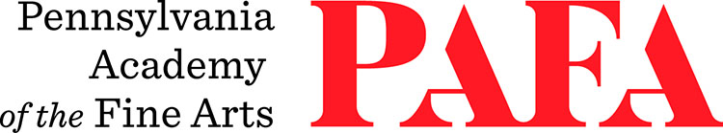
Continuing Education Programs
mATERIALS LIST
Course: Painting the Portrait and Clothed Figure
Instructor: David Wilson
Days/Dates: 6wks, Saturdays, October 31 – December 12
Time: 10:00 a.m. – 1:30 p.m.
Location: Studio 1, Historic Landmark Building
118 N. Broad Street, Philadelphia, PA 19102 (Use Student Entrance on Lenfest Plaza / Cherry Street

Suggested Materials: Below is a list of basic oil painting materials. Please feel free to add any additional colors or tools to this list that you prefer. Students are welcome to work in any PAFA-approved mediums, demonstrations will be in oils and charcoal. This course is open to anyone interested in working from the figure.
Oil Colors:
- Titanium White (larger tube)
- Yellow Ochre
- Cadmium Yellow Light
- Cadmium Red Light
- Burnt Sienna
- Dioxazine Purple
- Ultramarine Blue
- Viridian Green
- Raw Umber
- Ivory Black
Optional extras:
- Cadmium Green Light
- Alizarin Crimson
Brushes:
- 3 - 4 larger brushes, bristle or nylon (assorted filberts or flats, sizes 2 - 10)
- 2 or 3 small rounds, synthetic nylon (sizes 1 - 3)

Solvent: Odorless Mineral Spirits (Turpenoid or Gamsol) with a small cup
Linseed Oil: 1 small bottle
Palette: Wood or paper (approx. 11x14 - 12x16 in.)
One small palette knife
Canvas: Approximately 5-6 surfaces for painting (sizes 8x10” - 16x20”)

Paper Towels

