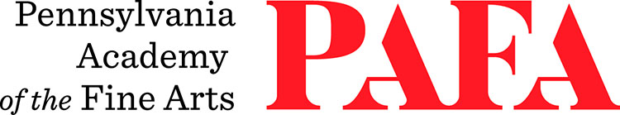
Continuing Education Programs
mATERIALS LIST
Course: Palette Knife Painting Workshop
Instructor: Shushana Rucker
Days/Dates: Saturday, December 5
Time: 9:00 a.m. – 5:00 p.m.
Location: Room 463 / Samuel M.V. Hamilton Building
128 N. Broad Street, Philadelphia, PA 19102 (Use Student Entrance on Lenfest Plaza / Cherry Street)

MATERIALS:
- Turpenoid
- Liquin Original, or linseed oil (or walnut alkyd, M. Graham)
- Blick Painting Knife - Small Spade #40, and Medium Spade #59 – and any others you want to try
- Primed panels – hardboard, plywood (primed with a textured gesso- not smooth. I use a
mixture of 1 part clear gesso to 3 parts opaque Liquitex gesso which adds a little grit to the surface)
- Cotton Rags or paper towels (highly recommend Viva brand)
- Palette (I use glass, but any surface that is clean and smooth will work)
- Assorted oil painting brushes
- Containers for medium and turpenoid
- References to work from (photos, sketches, objects)
- Assorted oil paints, bring a variety of colors. The colors below are the ones I use, I prefer Gamblin paints, but you can use whichever colors/paints you have on hand.
  - Titanium White
  - Ivory Black
  - Burnt Umber
  - Burnt Sienna
  - Yellow Ochre
  - Hansa Yellow Medium (similar to cadmium yellow medium)
  - Napthol Red (similar to cadmium red medium)
  - Quinacridone red or rose
  - Ultramarine Blue
  - Pthalo Blue
  - Pthalo Green

