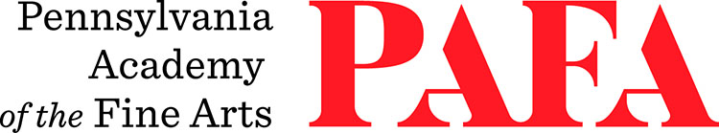
Continuing Education Programs
mATERIALS LIST
Course: Creative Ceramics: Functional Forms
Instructor: Matthew Courtney
Days/Dates: 6wks, Tuesdays, November 3 – December 8
Time: 12:30 p.m. – 3:30 p.m.
Location: Room 750, 7th Floor, Samuel M.V. Hamilton Building
128 N. Broad Street, Philadelphia, PA 19102 (Use Student Entrance on Lenfest Plaza / Cherry Street)

- Clay (available to purchase through the sculpture department, approximately $30 for a bag of clay)
- Short-bladed knife (like a paring knife)
- Needle tool
- 1-gallon bucket
- Any modeling tools you have (we will make a tool in the sculpture shop)
- Small sponge
- Small towel
- Pencil
- Paper

