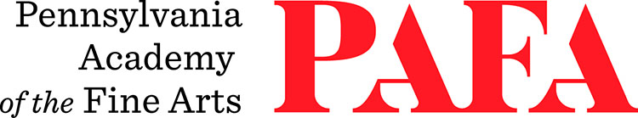
Continuing Education Programs
mATERIALS LIST
Course: Mixed Media Collage Workshop
Instructor: Anthony Ciambella
Days/Dates: Saturday & Sunday, October 31 – November 1
Time: 9:00 a.m. – 4:00 p.m.
Location: Room 610, 6th Floor / Samuel M.V. Hamilton Building
128 N. Broad Street, Philadelphia, PA 19102 (Use Student Entrance on Lenfest Plaza / Cherry Street)

Materials Needed
Bring some examples of any collages you’ve done, any materials you already use, and new ideas for an open class discussion. If collage is new to you, bring in magazines with pictures, fabrics, photographs, utility knife, scissors, brushes, mat boards, and any adhesives you might have. I’ll have some adhesives so you can experiment. Class begins with a PowerPoint covering the various types of materials that artists are using nowadays in mixed media projects, and the problems they face with installing and exhibiting their works.

Examples of Collage and Mixed Media

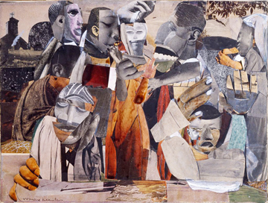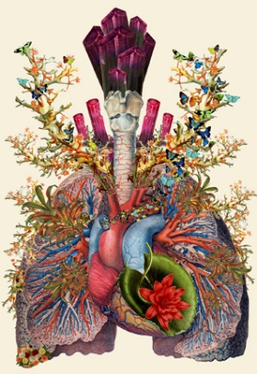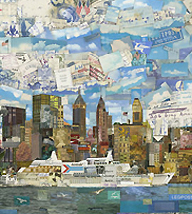
Romare Bearden Travis Bedel Vic Muniz

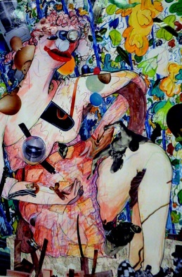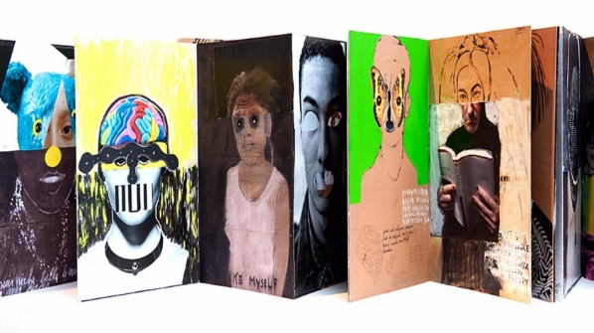
Gladys Nilsson Saskia Pintelon

