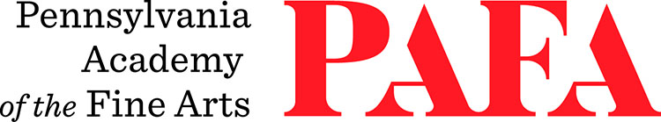
Continuing Education Programs
mATERIALS LIST
Course: Papermaking: Sheetforming to Sculpture
Instructor: Clay Tenhula
Days/Dates: 6wks, Thursdays, October 15 – November 19
Time: 12:30 p.m. – 3:30 p.m.
Location: Room 611, 6th Floor / Samuel M.V. Hamilton Building
128 N. Broad Street, Philadelphia, PA 19102 (Use Student Entrance on Lenfest Plaza / Cherry Street)

Please note that the lab fee will cover workshop materials.

It is recommended that students wear clothing and footwear that can get wet or waterproof. Please be mindful that it can run warm and humid in the Papermaking Studio. This class requires a lot of standing on concrete floors for extended periods of time. For questions about accommodations, please contact the CE office at continuinged@pafa.edu.

