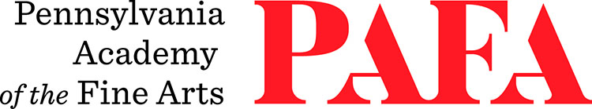
Continuing Education Programs
mATERIALS LIST
Course: Introduction to Photolithography
Instructor: Justine Ditto
Days/Dates: 8wks, Tuesdays, September 19 – November 17
Time: 12:30 p.m. – 3:30 p.m.
Location: Room 660, 6th Floor / Samuel M.V. Hamilton Building
128 N. Broad Street, Philadelphia, PA 19102 (Use Student Entrance on Lenfest Plaza / Cherry Street)

In this course, each student will produce one monochromatic photolithograph printed either in black or a color. Advanced students may have time to make two prints or one two-color print.

Due to the number of steps and detailed process in this medium, most of the work will be done during class time through direct instruction and with the instructor present. If you know you will miss more than one class, you may not be able to complete the course because there will be little time for re-demoing. Note: Only students with previous lithography experience will be permitted to print outside of class.

Materials:

- Drawing materials for Hand-drawn Films: 6B pencils, stabilo pencils, chinamarker, paintpen, acrylic, Rapidograph pen/ink, litho crayons
- A sheet of frosted mylar
- Newsprint
- Printmaking paper (e.g. Stonehenge, Rives BFK, Arches Cover, Somerset). Paper types will be covered during class.

Photoplates will be available for purchase in the Print Shop. Printing materials such as ink and chemistry are provided.

