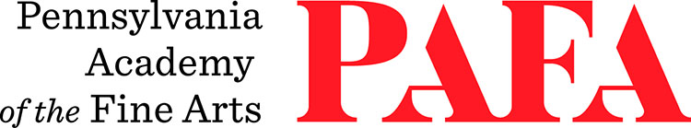
Continuing Education Programs
mATERIALS LIST
Course: Foundry: Intro/All-Levels
Instructor: Pavel Efremoff
Days/Dates: 12wks, Thursdays, September 10 – December 3 (No Class on November 26)
Time: 6:00 p.m. – 9:30 p.m.
Location: Room 781, 7th Floor / Samuel M.V. Hamilton Building, 128 N. Broad Street, Philadelphia, PA 19102

Leather boots or high-top shoes
Long sleeves and pants made of cotton or any other natural fiber

Other materials needed for the course will be discussed on the first day of class.

Please contact Pavel if you have any questions at: pavelefremoff@gmail.com

Sculpture Shop Access for CE Students

- Access to the Sculpture Shop for any CE student enrolled in a sculpture course begins on the first day of the scheduled class and ends on the last day of the scheduled class.
- Like all students, CE students may not use a shop while classes are in session in that area.
- All students using the shop outside of class time must be able to work independently with the materials and equipment they are using. CE students should feel free to ask the shop manager or shop assistants technical questions about proper use of tools or equipment.
- Matriculating students will take precedence over CE students when there is any over lapping need for equipment.

