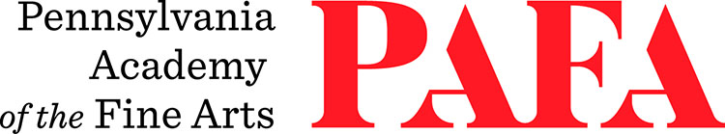
Continuing Education Programs
mATERIALS LIST
Course: Portrait in Pencil Workshop (In-Person)
Instructor: RA Friedman
Days/Dates: Saturday & Sunday, September 26 – September 27
Time: 9:00 a.m. – 4:00 p.m.
Location: Room 461, 4th floor, Samuel M.V. Hamilton Building
128 N. Broad Street, Philadelphia, PA 19102 (Use Student Entrance on Lenfest Plaza / Cherry Street)

Recommended materials:

- HB, 2B and 4B pencils
- Sharpener
- Kneadable eraser
- Masonite drawing board with clips
- Plain white sketching or drawing paper (not newsprint), 9”x12” or larger

