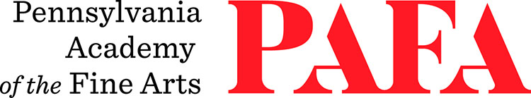
Continuing Education Programs
mATERIALS LIST
Course: Small Worlds: Small Format Oil Painting
Instructor: Shushana Rucker
Days/Dates: 6wks, Mondays, November 2 – December 7
Time: 6:00 p.m. – 9:00 p.m.
Location: Room 463 / 4th Floor Samuel M.V. Hamilton Building
128 N. Broad Street, Philadelphia, PA 19102 (Use Student Entrance on Lenfest Plaza / Cherry Street)

MATERIALS:
- Turpenoid
- Liquin Original, or linseed oil (or walnut alkyd, M. Graham)
- Blick Painting Knife - Small Spade #40, and/or any others you might want to use
- Primed small canvases or panels – no larger than 5”x7”
- Cotton Rags or paper towels (highly recommend Viva brand)
- Palette (I recommend a sta-wet palette with regular palette paper)
- An assortment of flat, round, and filbert oil painting brushes – including 000, 00, and 0 sized
- round brushes
- Containers for medium and turpenoid
- References to work from (photos, sketches, objects)
- Assorted oil paints, bring a variety of colors. The colors below are the ones I use, I prefer Gamblin
- paints, but you can use whichever colors/paints you have on hand.
- Titanium White
- Ivory Black
- Burnt Umber
- Burnt Sienna
- Yellow Ochre
- Hansa Yellow Medium (similar to cad yellow medium)
- Napthol Red (similar to cad red medium)
- Quinacridone red or rose
- Ultramarine Blue
- Pthalo Blue
- Pthalo Green

