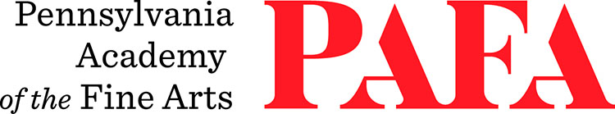
Continuing Education Programs
mATERIALS LIST
Course: Still Life Painting: Mastering Color and Composition
Instructor: Jill Rupinski
Days/Dates: 10wks, Thursdays, September 17 – November 19 (No Class on November 26)
Time: 9:00 a.m. – 12:00 p.m.
Location: Room 463, 4th Floor / Samuel M.V. Hamilton Building
128 N. Broad Street, Philadelphia, PA 19102 (Use Student Entrance on Lenfest Plaza / Cherry Street)

PAINTING SUPPLIES
All materials and their use will be discussed at the first class meeting. Drawing materials are welcome and useful.
If you have already purchased materials for the class with Al Gury, that's fine. Bring what you have.

Suggested Pigments:
  - Cadmium Red Medium or Naphthol Red (Winsor & Newton, Bright Red)
  - Alizarin Crimson or Quinacridone Red (W&N Permanent Red)
  - Hansa Yellow Light or Cadmium Yellow Light
  - French Ultramarine Blue
  - Cerulean Blue Hue
  - Venetian Red
  - Yellow Ochre (regular or light)
  - Burnt Sienna (Rembrandt is the brightest)
  - Mars Black or Ivory Black
  - White Titanium or Flake (Flake or Lead white is the preferred pigment)
Additional Materials:
  - Palette: Paper, Prepared wood or glass
  - Palette knife, metal with a “Dog Leg” bend
  - Palette Cup or small container with a lid to hold oil medium
  - For mixing a medium:
  - Two clear glass jars or clear high density plastic containers (#2 recycling symbol)
  - A nice option: Purchase Talenti Ice Cream 16 oz. container - Eat the Ice Cream, keep the container for class. Do not wash in dishwasher. Buy another jar and do the same.
  - Clean rags or paper towels
  - Masking Tape
Mediums & Thinners:
  - Turpenoid or Gamsol
  - Artist grade Linseed or Stand Oil
Brushes:
- Bristle flats and filberts (1/4 inch – 1 inch)
- Filbert and Round soft hair brush (sable or synthetic sable)
- 2 inch chip brush (Gesso brush)
Painting Surfaces:
- Painting surface - Canvas Board, Stretched Canvas, or Primed Hardboard
- Size range: no larger than 16x20, no smaller than or 11x14

