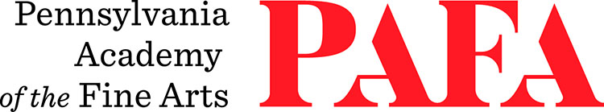
Continuing Education Programs
mATERIALS LIST
Course: Intuitive Abstraction
Instructor: Kassem Amoudi
Days/Dates: 10wks, Wednesdays, September 16 – November 18
Time: 12:00 p.m. – 3:30 p.m.
Location: Room 465, 4th Floor / Samuel M.V. Hamilton Building
128 N. Broad Street, Philadelphia, PA 19102 (Use Student Entrance on Lenfest Plaza / Cherry Street)

Please feel free to bring whatever materials you have and are accustomed to using. The list below is a suggested one only.
- Acrylic paint preferred but oil is ok, any colors in addition to black and white
- Acrylic matte medium and gloss medium; or Turpenoid and oil for oil
- Brushes – various sizes, round and flat, up to 1 ½- to 2 ½-inch depending on canvas size
- Sponges or rags for applying colors too
- Blue painter's tape or masking tape
- Canvases (stretched or unstretched) or paper – larger is better
- For unprimed canvas you can prime with clear gesso (if you want to keep the canvas looking unprimed) or white or colored gesso
- Palette
- Palette knives
- Jars or plastic containers for mixing and saving paints
- Rags for cleaning
- Charcoal, pencil
- Watercolor, gouache, or pastel (optional)

