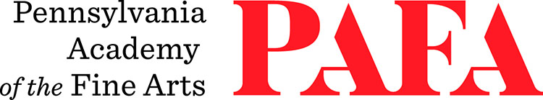
Continuing Education Programs
mATERIALS LIST
Course: The Figure in Clay Workshop
Instructor: Colleen O'Donnell
Days/Dates: Saturday & Sunday, November 7 – November 8
Time: 9:00 a.m. – 4:00 p.m.
Location: Room 740, 7th Floor / Samuel M.V. Hamilton Building
128 N. Broad Street, Philadelphia, PA 19102 (Use Student Entrance on Lenfest Plaza / Cherry Street)

Materials:
- 25 lbs of air dry clay (AMACO or Laguna clay can be purchased at Blick Art Materials, a short walk from PAFA)
- Wood or plastic Sculpture tools
- Plastic garbage bag
- Water spritzer

