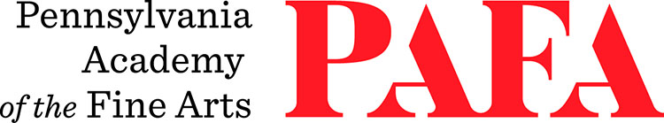
Continuing Education Programs
mATERIALS LIST
Course: Metal Sculpture
Instructor: Steve Nocella
Days/Dates: 10wks, Saturdays, September 19 – October 21
Time: 12:00 p.m. – 3:30 p.m.
Location: Room 720, 7th Floor / Samuel M.V. Hamilton Building
128 N. Broad Street, Philadelphia, PA 19102 (Use Student Entrance on Lenfest Plaza / Cherry Street)

Notes
- The $65 lab fee for this course covers the cost of gas and equipment maintenance.
- Students should come prepared to purchase the metal of their choice after meeting with the instructor on the first day of class.
- Students should be prepared to buy welding gloves and 2–4 welding rods.
- Advanced students are strongly advised to purchase their own torches.

Safety Clothing – Please wear the following to class at all times:
- Clothing of natural fibers – wool is least flammable, cotton acceptable
- Long pants
- Long sleeves, cuffs buttoned
- Shirt tails tucked in
- Heavy work shoes (high tops)
- Safety glasses (goggles available at the sculpture shop)
- Hair, if long, tied back
- No dangling earrings and other accessories

For questions, please contact the instructor: stevennocella@gmail.com.

