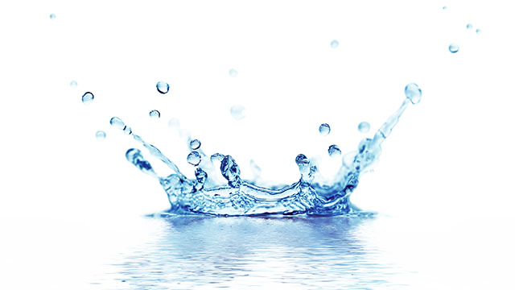
First Session – Is an introduction to vocabulary & the materials with
preparatory demonstrations

FIRST CLASS: Review all materials and accoutrements, paper preparations & color mixing
Transparent Watercolors: in tubes, artist quality. Cake and gouache colors will be introduced.
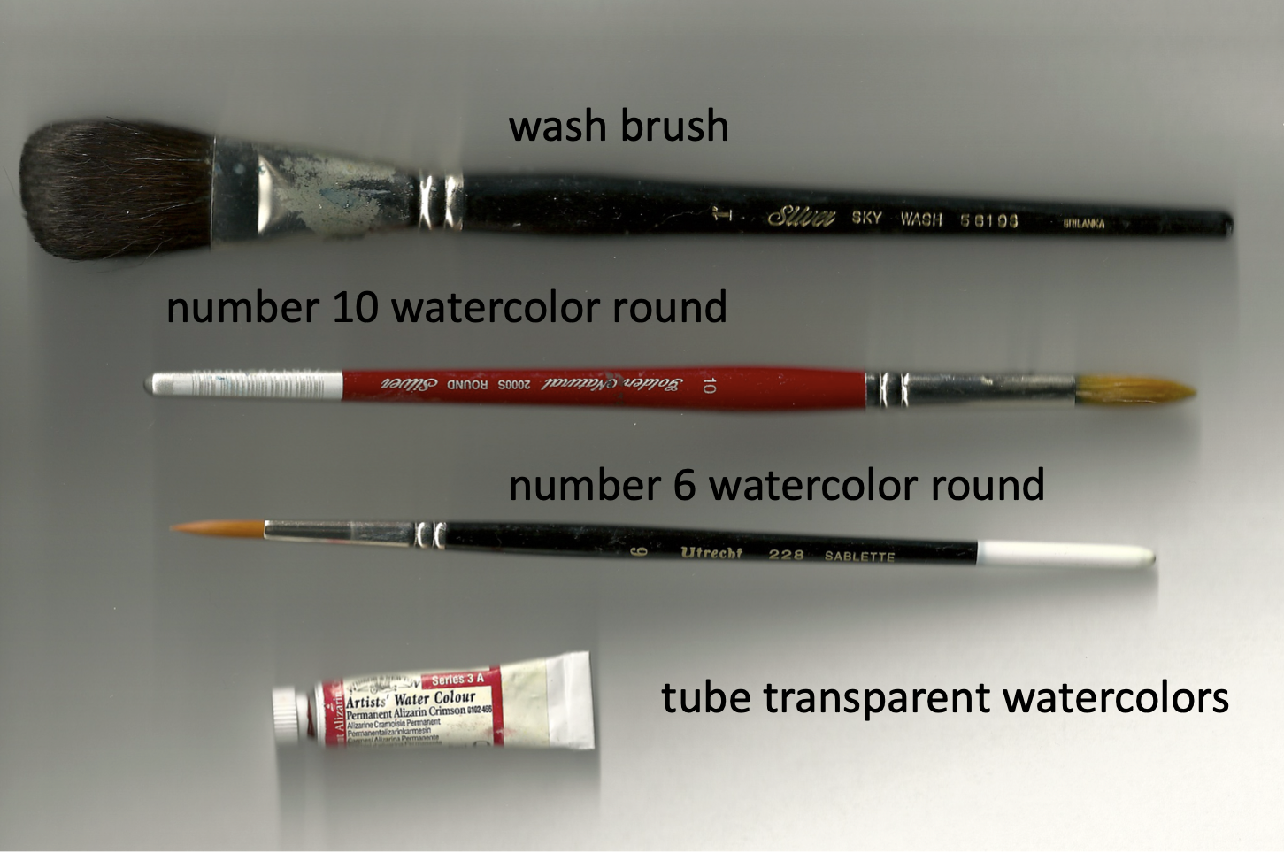
Paper- sheets first - blocks will be demonstrated: Bring what you have to start (single sheets to start). However, 300lb is best (you will be encouraged to try it). Sheets are usually 22 x 30 inches; it will be cut into smaller pieces), smooth or slightly textured. Two good brands are Arches or Fabriano.
Brushes: Three brushes, synthetic and inexpensive is good to start.
Inexpensive brushes will serve the medium very well.
Synthetic watercolor brushes are good, but not nylon brushes.
• _Wash brushes are often of squirrel hair; a one-inch wash brush is a good starter.
• _A #6, #10 or #12 watercolor round will serve the needs of the first two classes.

TRANSPARENT WATERCOLORS in tubes; artist quality is best.
Basic colors enable mixing other colors.
Various mediums and other colors will be introduced.
• _Ultramarine Blue
• _Phthalo Blue
• _Bright Red and/or Alizarin Crimson
• _Light Yellow or Hansa Yellow
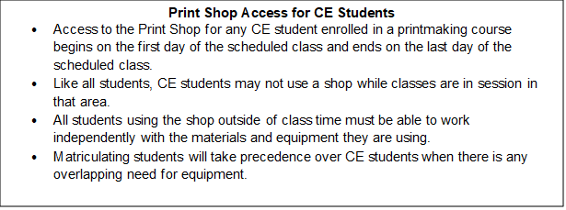
• _Light Cadmium Yellow
• _Burnt Sienna
• _Burnt Umber

Other supplies: pencil, plastic containers with lids & more will be shown.

CALENDAR SUMMARY
basic technical painting vocabulary exercises will be practiced
assignments include objects, organic items, flowers, portraits tonyrosatiprint.com

