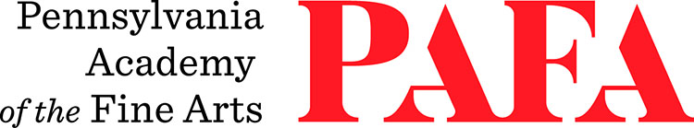
Continuing Education Programs
mATERIALS LIST
Course: Woodcut Printmaking
Instructor: Rebecca Gilbert
Days/Dates: 6wks, Wednesdays, October 14 – November 18
Time: 12:00 p.m. – 3:30 p.m.
Location: 660 Print Shop, 6th Floor / Samuel M.V. Hamilton Building
128 N. Broad Street, Philadelphia, PA 19102 (Use Student Entrance on Lenfest Plaza / Cherry Street)

Tools
I will have some carving tool sets available for use during class, so it’s not imperative that everyone purchases their own tools. If you would like to purchase your own tools, I recommend Powergrip brand tool sets or Flexcut tool sets. I will bring examples of both sets of tools to the first class, so you can try them out and decide which you think will work better for you.
Wood
I very strongly recommend using shina plywood in this class. I’ll have a limited amount of shina available for purchase in two different sizes: 9” x 12” and 12” x 18”. Alternatively, you can order shina plywood from McClain’s Printmaking supply. Note it will be shipping from Oregon, so sometimes takes a little while. I will discuss other wood options on the first day of class.
All students should bring:
- One pad or roll of tracing paper
- One pad of newsprint (This needs to be larger than your wood block.)
- Roll of masking tape or artist’s tape
- Rubber gloves or nitrile gloves to wear when using solvents
- Rags
- Apron
- Pencil
- An idea! I will show numerous examples on the first day of class in order to help get your creative juices flowing, and to give you an idea what can be achieved.
Oil-based ink and solvents are included in your studio fee and will be supplied by PAFA.

