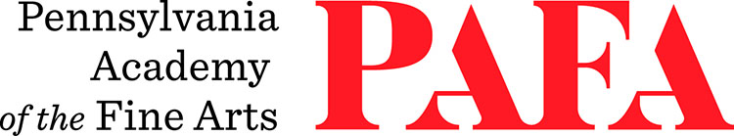
Continuing Education Programs
mATERIALS LIST
Course: Holistic Figure Drawing
Instructor: John Horn
Days/Dates: 12wks, Wednesdays, September 16 – December 2
Time: 9:00 a.m. – 12:00 p.m.
Location: Room 461, 4th Floor / Samuel M.V. Hamilton Building
128 N. Broad Street, Philadelphia, PA 19102 (Use Student Entrance on Lenfest Plaza / Cherry Street)

Materials:
For experienced students, please feel free to bring in whatever materials you are comfortable with. For those of you who would like a materials list, please see below.

- A pad 11” X 14” or larger of medium quality paper. Strathmore, Canson, Blick all sell this type of paper. NO NEWSPRINT.

- Graphite pencils. HB, 2B, 4B. Faber Castile, Generals, Derwent and Blick are all good choices.

- Charcoal. Nitram or compressed charcoal pencils. Wolff’s Carbon Pencils set or General’s.

- Sharpener, utility knife, sandpaper for sharpening.

- Erasers. kneaded, pink pearl, Staedtler.

- (Optional) - A red or burnt sienna pencil. Faber Castile.

