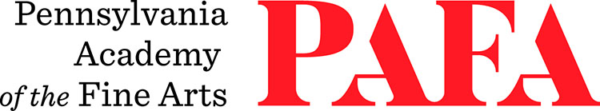
Continuing Education Programs
mATERIALS LIST
Course: Paint-and-Print Monotype Abstraction
Instructor: Justine Ditto
Days/Dates: 6wks, Mondays, November 2 – December 7
Time: 12:30 p.m. – 3:30 p.m.
Location: Room 660, 6th Floor / Samuel M.V. Hamilton Building
128 N. Broad Street, Philadelphia, PA 19102 (Use Student Entrance on Lenfest Plaza / Cherry Street)

- Akua Brand thin Plexi-Glass printing plates (not thick ones) Akua Printmaking Plates | BLICK Art Materials
- Etching Needles and other scribing tools of your choice
- Printmaking Paper - a variety (recommended brands: Stonehenge, Arches Cover, Somerset)
- A variety of alternative papers of your choice (e.g.: Mylar, vellum, Yupo, handmade paper, etc.)
- Drawing materials of your choice such as graphite, marker, crayon, pastel, pen, and ink
- Painting materials of your choice such as oil paint, acrylic paint, watercolor, and/or gouache (you should have at least one oil-based option and one water-based option in a variety of colors)
- A variety of brushes
- Newsprint
- Masking Tape
- Disposable gloves for cleaning
- X-Acto knife

